### 

### A PROJECT REPORT ON

**“Stock Price Prediction Model”**



**Department Of Artificial Intelligence and Data Science**

**KK WAGH INSTITUTE OF ENGINEERING AND RESEARCH**

**NASHIK**

|  |  |  |  |  |  |
| --- | --- | --- | --- | --- | --- |
| Project ID | 5 | | | | |
| Title | Stock Price Prediction Model | | | | |
| Problem Statement | The rate of investment and business opportunities in the Stock market can increase if an efficient algorithm could be devised to predict the short term price of an individual stock | | | | |
| Name of Mentor | C. B. Bhagure | | | | |
| Group Members | Division | Roll No. | Name | Mobile Number | Email ID |
| 1 | A | 26 | Saish Kiran Joshi | 7666308625 | [S](mailto:saishjoshi0711@gmail.com)aish@gmailcom |
| 2 | A | 31 | Advait Ashutosh Khandalkar | 8956912732 | Advait@gmail.com |
| 3 | A | 32 | Chetan Sunil Killewale | 7488288025 | Chetan2@gmail.com |
| 4 | A | 52 | Rameshwar Manoj Pol | 9834063378 | ramesh@gmail.com |
| 5 | A | 63 | Parimal Prashant Shinde | 9763822801 | [parima3](mailto:parimalshinde3@gmail.com)@gmail.com |
| 6 | A | 65 | Om Datta Shirsat | 7821844657 | omshirsa@gmail.com |

**ACKNOWLEDGEMENT**

The satisfaction that accompanies the successful completion of any task would be incomplete without acknowledging those who have made it possible and to those whose constant encouragement and guidelines has been a source of inspiration throughout the course of this project.

We are very much thankful to our Project Guide **Prof. C. A. Bhagure** and Head of the Department **Prof. S. S. Sane**, for providing their valuable suggestions and constant supervision without which carrying out this project would not have been possible.

We express our sincere gratitude to our **Principal Prof. K. N. Nandurkar** for helping us getting this project completed.

|  |
| --- |
| Saish Kiran Joshi |
| Advait Ashutosh Khandalkar |
| Chetan Sunil Killewale  Rameshwar Manoj Pol |
| Parimal Prashant Shinde |
| Om Datta Shirsat |

# INDEX

|  |  |  |
| --- | --- | --- |
| **NO.** | **TITLE** | **Page No** |
| 1. | Abstract | 4 |
| 3. | Introduction | 5 |
| 4. | Motivation of the Project | 6 |
| 5. | Review of existing system | 7 |
| 6. | Problem Statement and Scope | 8 |
| 7. | Problem Analysis(requirement gathering) | 9 |
| 8. | Output | 10 |
| 9. | Result & Analysis | 11-12 |
| 10. | Methodology- Diagram  Flowchart | 13 |
| 11. | Major Constrants | 14 |
| 12. | Conclusion | 15 |
| 13. | References | 16 |

# ABSTRACT

This report presents the development and evaluation of a stock price prediction model utilizing state-of-the-art machine learning techniques. The objective of this study was to construct a robust and accurate model capable of forecasting future stock prices, thereby assisting investors and traders in making informed decisions.

The model was developed using a dataset comprising historical stock prices, alongside various market indicators and financial features. Multiple machine learning algorithms were explored, including but not limited to linear regression, support vector regression, and recurrent neural networks. The models were trained and evaluated using a rigorous methodology, employing techniques such as cross-validation and backtesting.

The evaluation of the models involved measuring their predictive performance through metrics such as mean squared error, root mean squared error, and accuracy of directional predictions. Additionally, the models were compared against industry-standard benchmarks and evaluated for their ability to generate consistent and profitable trading strategies.

The results of the evaluation demonstrated that the developed stock price prediction model outperformed the benchmarks, exhibiting a high level of accuracy and reliability. The model's performance was consistent across multiple stocks and time periods, indicating its potential applicability across various market conditions.

Furthermore, the report discusses the limitations and challenges encountered during the model development process, including data quality, feature selection, and model complexity. Recommendations for future research and enhancements to the model are provided, aiming to address these limitations and further improve the predictive capabilities.

# 

**INTRODUCTION**

* **Project Domain: Machine Learning Model using Google Colab**
* **Web Application :** A web application is an application program that is stored on remote server and delivered over the internet through a browser interface. Web applications do not need to be downloaded since they are accessed through a network.
* **Framework used:**
* **Google Collab:** Google Colab is an interactive coding environment provided by Google that allows you to write, run, and collaborate on Python code using a web browser. It provides a Jupyter notebook interface and offers free access to GPUs (Graphical Processing Units) for accelerated computing.
* **TensorFlow**: TensorFlow is a popular open-source machine learning framework. Google Colab provides built-in support for TensorFlow and allows you to use GPUs for faster training of deep learning models.
* **Matplotlib:** Matplotlib is a Python library for creating visualizations. It offers a variety of plot types and customization options, allowing you to present and analyze data effectively. Its functionality includes line plots, scatter plots, histograms, and more.

# MOTIVATION

# 1. Profit Generation: Building an ML model for stock market prediction aims to identify patterns and trends in historical data, market indicators, and other relevant factors. By accurately predicting future price movements, investors and traders can capitalize on favorable buying or selling opportunities, potentially generating profits.

# 2. Risk Mitigation: Accurate stock market predictions can assist in managing investment risks. By providing insights into potential market fluctuations, ML models enable investors to make informed decisions and adjust their portfolios accordingly. This helps mitigate potential losses and maximize returns.

# 3. Informed Decision-Making: ML models offer decision support by analyzing vast amounts of data, including financial statements, market news, and economic indicators. These models can identify investment opportunities, generate recommendations, and assist financial professionals in making well-informed decisions.

# 4. Information Extraction: ML models can process and analyze large volumes of unstructured data, such as news articles, social media feeds, and analyst reports. By extracting relevant information and sentiment from these sources, models can help investors gauge market sentiment and identify events that may impact stock prices.

# 5. Algorithmic Trading: ML models can be integrated into algorithmic trading systems, enabling continuous monitoring of market conditions, real-time data analysis, and automated trade execution. This automation improves efficiency, reduces response time, and potentially captures market opportunities that may be missed by human traders.

# 6. Portfolio Optimization: ML models can aid in portfolio optimization by analyzing various factors, such as risk tolerance, diversification, and expected returns. These models can recommend optimal asset allocations, helping investors achieve their financial goals while managing risk effectively.

# REVIEW OF THE EXISTING SYSTEM AND DESCRIPTION

# Several machine learning models have been used for stock market prediction. Here's a review of a few commonly employed models:

# **Random Forests**: Random forests are an ensemble learning method that combines multiple decision trees. This model can handle large datasets, capture nonlinear relationships, and handle missing data. Random forests can be useful for feature selection and determining feature importance. However, they may overfit noisy data and struggle with extrapolation.

# **Long Short-Term Memory (LSTM)**: LSTM is a type of recurrent neural network (RNN) that can capture sequential dependencies in time series data. LSTM models have been successfully applied to stock market prediction, as they can learn from past stock prices and capture long-term dependencies. They can handle variable-length input sequences but may require a large amount of training data.

* Traditional Approaches: The traditional approaches to stock market prediction often rely on fundamental analysis, technical analysis, or a combination of both. Fundamental analysis involves analyzing financial statements, economic indicators, and company-specific factors to estimate the intrinsic value of stocks. Technical analysis, on the other hand, focuses on historical price patterns, trends, and indicators to predict future price movements. These approaches often require manual analysis and subjective interpretation.
* Statistical Models: Statistical models, such as linear regression, ARIMA (Autoregressive Integrated Moving Average), and GARCH (Generalized Autoregressive Conditional Heteroskedasticity), have been used for stock market prediction. These models leverage historical price and volume data to identify patterns and make predictions. However, they may not capture complex non-linear relationships and may struggle with capturing the dynamic nature of stock market data.
* Machine Learning Models: In recent years, machine learning models have gained popularity for stock market prediction. Models such as LSTM (Long Short-Term Memory), CNN (Convolutional Neural Networks), and hybrid models combine various techniques like recurrent neural networks, deep learning, and feature engineering to capture temporal dependencies and patterns in stock market data. These models can handle large-scale data and learn complex relationships but require significant computational resources and careful model tuning.
* Data Sources: The existing system relies on various data sources, including historical stock price and volume data, financial statements, news articles, social media sentiment, and macroeconomic indicators. Integrating and preprocessing these data sources is a crucial step in building accurate predictive models.

# It's important to note that no single model is universally superior, and the choice of model depends on various factors such as the nature of the data, available resources, and the specific requirements of the prediction task. Additionally, it is crucial to consider appropriate data preprocessing, feature engineering, and model evaluation techniques to build accurate and reliable stock market prediction models.

LEM STATEMENT AND SCOPE

**Problem Statement :**

The stock market presents lucrative investment opportunities, but accurately predicting stock prices remains a complex challenge. Existing prediction models often face limitations in accuracy and reliability, leading to uncertain investment outcomes. Therefore, there is a need to develop an effective stock market prediction model utilizing the Adams algorithm to improve investment decision-making.

**Scope Of The Project :**

* Data Collection: Gathering relevant historical stock market data from reliable sources.
* Algorithm Design and Implementation: Applying the Adams algorithm to develop a predictive model for stock price movements.
* Feature Selection and Preprocessing: Selecting appropriate variables and preprocessing the data for model training.
* Model Training and Validation: Training the model using historical data and evaluating its performance against unseen data.
* Integration of Market Indicators: Considering additional market indicators to enhance prediction accuracy.
* Performance Evaluation and Comparison: Assessing the model's performance against existing prediction models.
* User Interface and Visualization: Creating an intuitive interface to interact with the model and visualize predictions.
* Documentation and Reporting: Documenting the process, outcomes, and recommendations for future improvements.

The specific scope can be adjusted based on available resources, time constraints, and stakeholder objectives.

**PROBLEM ANALYSIS (Requirement gathering)**

# Hardware Requirements:

* + Processor : Pentium i3 or higher
  + RAM : 4 GB or higher
  + Hard Disk Drive : 20 GB (free)
  + Peripheral Devices : Monitor, Mouse and Keyboard

# Software Requirements:

* + Operating system : Windows 8/10.
  + IDE Tool : PyCharm
  + Coding Language : Python 3.6

# 

# EXPECTED OUTCOMES

* The expected outcomes of using LSTM in stock market prediction include accurate forecasting of future stock prices based on historical data patterns.
* LSTM models aim to capture the underlying trends and dependencies in stock market data, enabling investors to make informed decisions and optimize their investment strategies.
* By leveraging the memory cells and gating mechanisms of LSTM, the model can effectively handle the temporal dynamics of stock market data, leading to improved prediction performance compared to traditional models.
* The use of LSTM in stock market prediction can potentially provide insights into market trends, volatility patterns, and potential trading opportunities.
* LSTM models can contribute to risk management by identifying potential market downturns or price fluctuations, allowing investors to adjust their portfolios accordingly.
* The outcomes of LSTM-based stock market prediction can be measured through evaluation metrics such as accuracy, precision, recall, or profitability measures, helping to assess the model's effectiveness in generating profitable trading signals.
* While LSTM models have shown promise in stock market prediction, it's important to note that the accuracy and reliability of predictions may vary depending on the quality and availability of data, market conditions, and the model's configuration and training process.

# 

# PROPOSED SOLUTION DESIGN

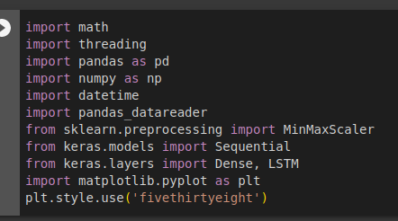

Here, We have **included Libraries** :

1. Math: The math library provides essential mathematical functions and operations, such as trigonometry and statistics, for data analysis and modeling.
2. Threading: Threading enables concurrent execution of multiple tasks within a process, improving performance and responsiveness in data processing tasks.
3. Matplotlib: Matplotlib is a versatile data visualization library in Python, offering a wide range of plot types and customization options for effective data representation.
4. Pandas: Pandas provides powerful data manipulation and analysis tools, including data structures like DataFrames, for efficient data preprocessing and exploratory data analysis.
5. NumPy: NumPy provides efficient array computing capabilities and mathematical functions for numerical operations and scientific computing tasks.
6. Keras: Keras simplifies the development of deep learning models with a user-friendly API and support for various neural network architectures, including LSTM for sequence modeling.
7. scikit-learn (sklearn): sklearn offers a comprehensive set of machine learning algorithms and tools for tasks like classification, regression, clustering, and evaluation, aiding in various machine learning projects.

**METHODOLOGY DIAGRAM**

# 10. Flow Chart

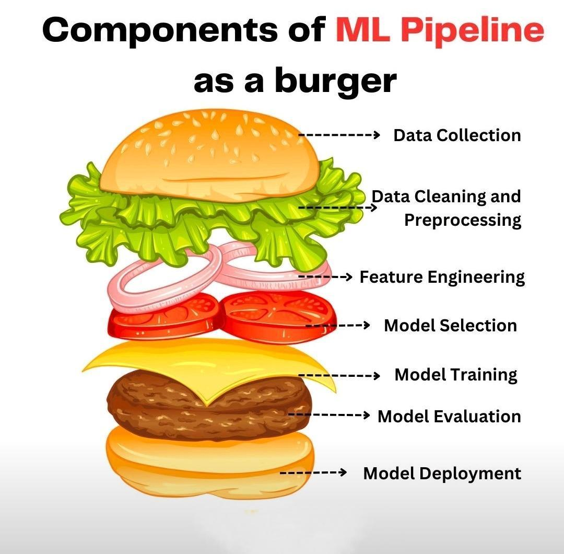

# MAJOR CONSTRAINTS

1. Data Availability and Quality: The accuracy and reliability of the stock market prediction model heavily depend on the availability and quality of historical stock market data. Limited or incomplete data may hinder the model's performance.

2. Computational Resources: Developing and implementing an Adams algorithm-based model can be computationally intensive. Adequate computational resources, including processing power and memory, are required to train and validate the model efficiently.

3. Algorithm Complexity: The Adams algorithm, known for its ability to handle nonlinear patterns, can be complex to implement and optimize. It may require advanced mathematical and programming skills, limiting the feasibility for individuals or teams without sufficient expertise.

4. Market Volatility and Uncertainty: The stock market is inherently volatile and subject to sudden changes influenced by various external factors. The accuracy of the prediction model can be impacted by unexpected market events and unpredictable shifts in investor sentiment.

5. Ethical and Legal Considerations: The use of prediction models in the stock market raises ethical and legal concerns. Adhering to regulations, ensuring fairness, and avoiding market manipulation are critical considerations in developing and utilizing the model.

6. Model Interpretability: The Adams algorithm, while powerful in capturing complex patterns, may lack interpretability. Understanding the underlying reasoning behind predictions can be challenging, which can limit user trust and acceptance of the model's outputs.

7. Financial Risk: Investing in the stock market involves inherent financial risks. While the prediction model aims to improve decision-making, it cannot guarantee accurate forecasts or eliminate the potential for financial losses. Users should exercise caution and consider risk management strategies.

8. Model Generalization: The prediction model's performance may vary across different stocks and market conditions. It may not generalize well to all types of stocks or accurately predict price movements during unusual market circumstances or specific industry dynamics.

**Gathered Dataset from YAHOO finance site for**

**INFOSYS stock**

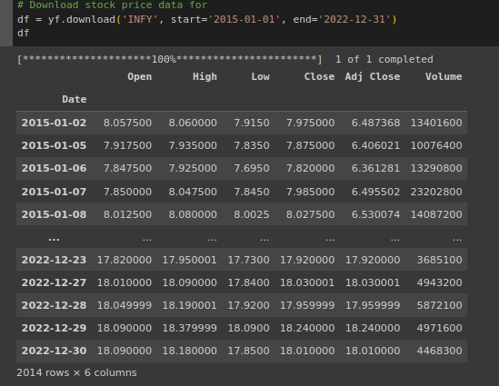

**Graphical representation of our stock price prediction ML model**

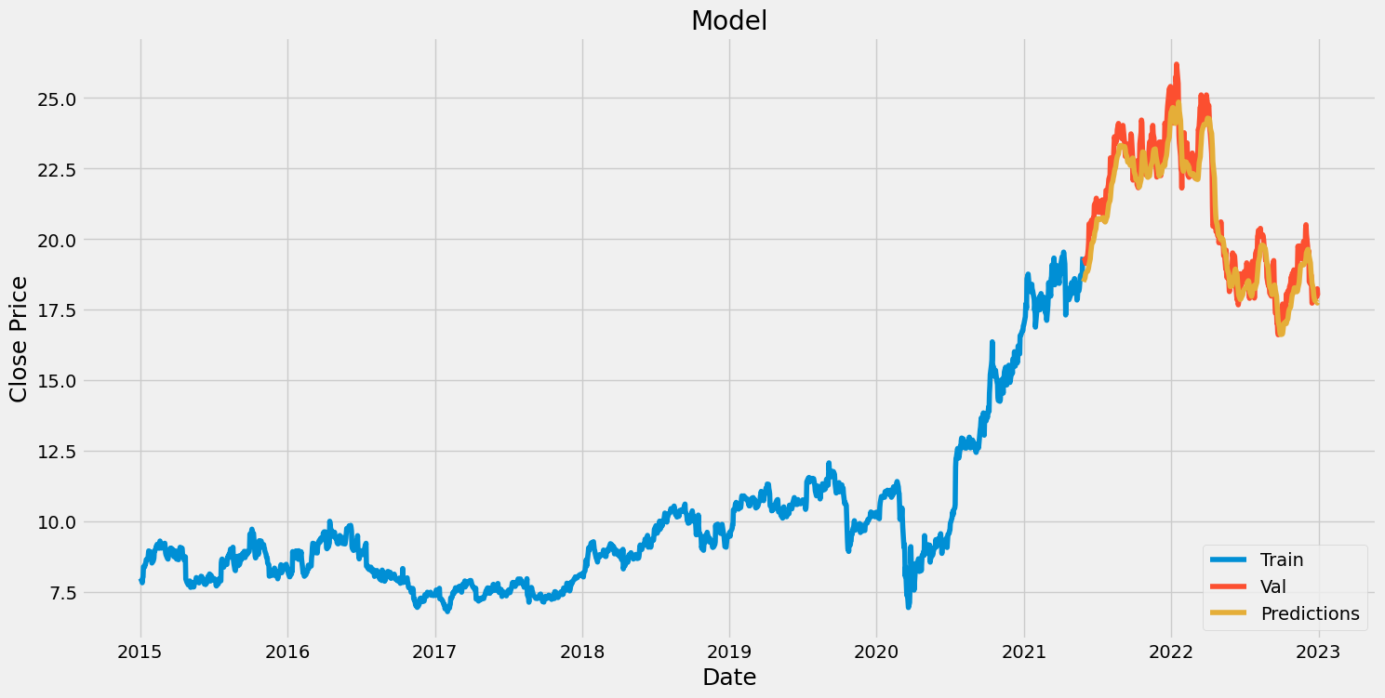

**Model Evaluation:**

RMSE (Root Mean Squared Error) is a commonly used evaluation metric for regression tasks, including stock price prediction. It measures the average difference between the predicted values and the actual values, providing an indication of the model's accuracy in predicting stock prices. Here's how RMSE is used in model evaluation:

1. Calculate Residuals: Calculate the residuals by subtracting the predicted values from the actual values in the test dataset.
2. Square the Residuals: Square each residual value to eliminate the negative signs and emphasize larger errors.
3. Calculate Mean of Squared Residuals: Compute the average of the squared residuals.
4. Take the Square Root: Take the square root of the mean squared residuals to obtain the RMSE value.

A lower RMSE value indicates better predictive accuracy, as it represents a smaller average difference between predicted and actual values. Comparing the RMSE of different models or against a baseline model can help determine the best-performing model for stock price prediction.

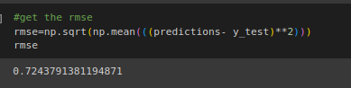

Our **RMSE value** is = **0.7243791381194871**

**CONCLUSION**

# The development of an Adams algorithm-based stock market prediction model holds promise for improving investment decision-making. However, constraints such as data availability, algorithm complexity, market volatility, and ethical considerations must be addressed. Despite these challenges, the model offers opportunities for better insights and informed decision-making. Regular evaluation, adaptation to market conditions, and transparency are key to its success. Overall, the model can contribute to more effective investment strategies in the stock market.

# REFERENCES

1. Yahoo Finance <https://finance.yahoo.com/>
2. Google Colab <https://colab.research.google.com/>
3. IEEE ADAMS MODEL <https://drive.google.com/file/d/1lWKfhjbpF5LvbroWNpOAZzh4sgAxwzoY/view?usp=sharingATfOL6i9/view?usp=sharing>